FIRST LIGHT
MARCH 1, 2020
8:45 A.M. WORSHIP

“Draw near to God and He will draw near to you.” James 4:8 (NKJV)

Praise Set What a Friend
Beautiful Day
Children’s Dismissal (4 & 5 Year Olds - 1st & 2nd Graders)
*Offering Marvelous Light
Hosanna (Praises Rising)
Message Pastor
Depressed? Take Vitamin D!
Joshua 1:9; Isaiah 41:10; James 4:8

Invitation Breathe
Just a thought: Anxious? Take Vitamin A! (Romans 8:28; Philippians 4:4-7; James 1:2-4); Blue? Take Vitamin B! (Psalm 103:1-12); Crushed? Take Vitamin C! (1 Peter 5:6-11), and today, Depressed? Take Vitamin D! (Joshua 1:9; Isaiah 41:10; James 4:8)

Examples of depression in the Bible!
Examples of depression from our lives!
Remedies for depression-Take Vitamin D!
- Do not be discouraged - Joshua 1:9!
- Do not be dismayed - Isaiah 41:10!
- Draw near to God - James 4:8!
As we go: God is right here right now! However dark the cloud of depression might be, please know how much God loves you and that He is working in your life and in your situation. Don’t give up!
SALT AND LIGHT
MARCH 1, 2020
11:00 A.M. WORSHIP

Prelude
Call to Worship ‘Til the Storm Passes By
Soloist: Steve Garrison
Opening Prayer Tonya Garrison
Hymn #730 Stand Up, Stand Up for Jesus
Welcome Pastor
Children’s Dismissal (4 & 5 Year Olds - 1st & 2nd Graders)
Awesome God
Our God is an awesome God; He reigns from heaven above
With wisdom, pow’r and love; Our God is an awesome God!
Our God is an awesome God; He reigns from heaven above
With wisdom, pow’r and love; Our God is an awesome God!
CCLI# 1466496
Hymn #401 The Church’s One Foundation
Offertory & Choir Dismissal
Scripture Reading Pastor
Joshua 1:9; Isaiah 41:10; James 4:8
Morning Prayer Pastor
Worship in Song Jim Bishop
Message Pastor
Depressed? Take Vitamin D!
Invitation Hymn #519 Jesus Is Lord of All
Benediction Pastor
Response to Benediction #349 O How He Loves You and Me
6:00 P.M. – Evening Worship
Francis Chan, Letters to the Church
SUNDAY:
8:45 - First Light (LEC)
9:45 - Sunday School
11:00 - Salt and Light Service (Sanctuary)
4:00 - G.L.O.W.
5:00 – Youth Praise Band
G.L.O.W Jr.
6:00 - Evening Worship
Powerhouse (4 yr olds – 3rd Graders)
Children’s Bible Drill (4th – 6th Graders)
Youth Discipleship
Adult Handbells

MONDAY:
8:30 - 11:00 - LEC/Gym Open for Walkers

TUESDAY:
8:30 - 11:00 - LEC/Gym Open for Walkers
10:30 - GriefShare
6:00 - Knit, Crochet, Pray
Upward Celebration and Awards Night
R-S Central High School
WEDNESDAY:
4:30 - Senior Adult Choir
5:00 - Staff Fellowship Supper Serving Time
5:30 - Choir Helpers Fellowship Supper Serving Time
5:45 - 6:15 - Fellowship Supper Serving Time
6:15 - 7:00 - Preschool and Children’s Choirs
6:30 - Prayer Meeting
6:30 - Youth Discipleship
7:00 - Children’s Mission Groups
7:30- Adult Choir Rehearsal
8:30 - Adult Praise Band
THURSDAY:
8:30 - 11:00 - LEC/Gym Open for Walkers
9:30 - Senior Adults depart - Shopping at Hamrick’s
6:30 - Anchored Bible Study
FRIDAY:
8:30 - 11:00 - LEC/Gym Open for Walkers

NURSERY– Sunday, March 1, 2020

8:30 A.M. – Kim Bridges, Angela Dufford, David & Ann Vo,
Rosemari Holland, Missy Flack

11:00 A.M. - Rae Hodge, Tommy Wilson, Janet Atkins
Courtney Atkins, Denise Arrowood

6:00 P.M. – Kim Bridges, Angela Dufford

CHILDREN’S WORSHIP - Sunday, March 1, 2020

8:30 A.M. - Tonya Garrison, Alison Gantt
11:00 A.M. - Tonya Garrison, Alison Gantt
FLORENCE BAPTIST CHURCH
201 South Broadway Street, Forest City, North Carolina
828-245-5411
www.florencechurch.net






Dr. Bobby Gantt, Pastor
Jesus, full of the
Holy Spirit…
was led by the Spirit
in the desert,
where for forty days
He was tempted
by the devil

Luke 4:1-2a
Rev. Scott Haynes, Minister of Music
Tonya Garrison, Minister of Children & Christian Education
Rev. David Cox, Minister of Youth & Instructional Technology
Teresa Skinner, Office Manager
Ashlee Kallay, Church Hostess
Pam McKeithan, Organist
Sharon Haulk, Pianist
Tommy Wilson, Custodian
Carrol Calhoun, Custodial Assistant

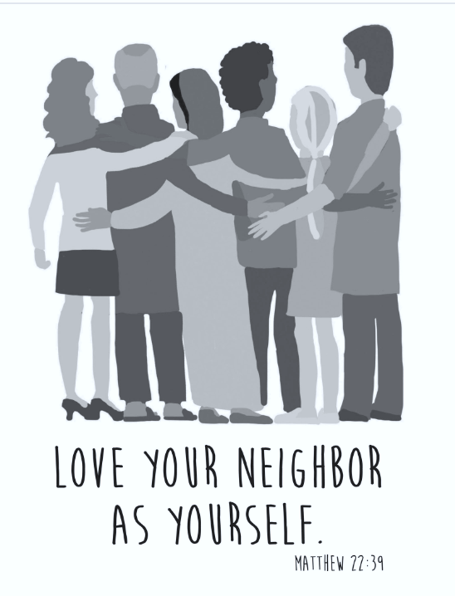

FLORENCE BAPTIST CHURCH
201 South Broadway Street, Forest City, North Carolina
828-245-5411
www.florencechurch.net

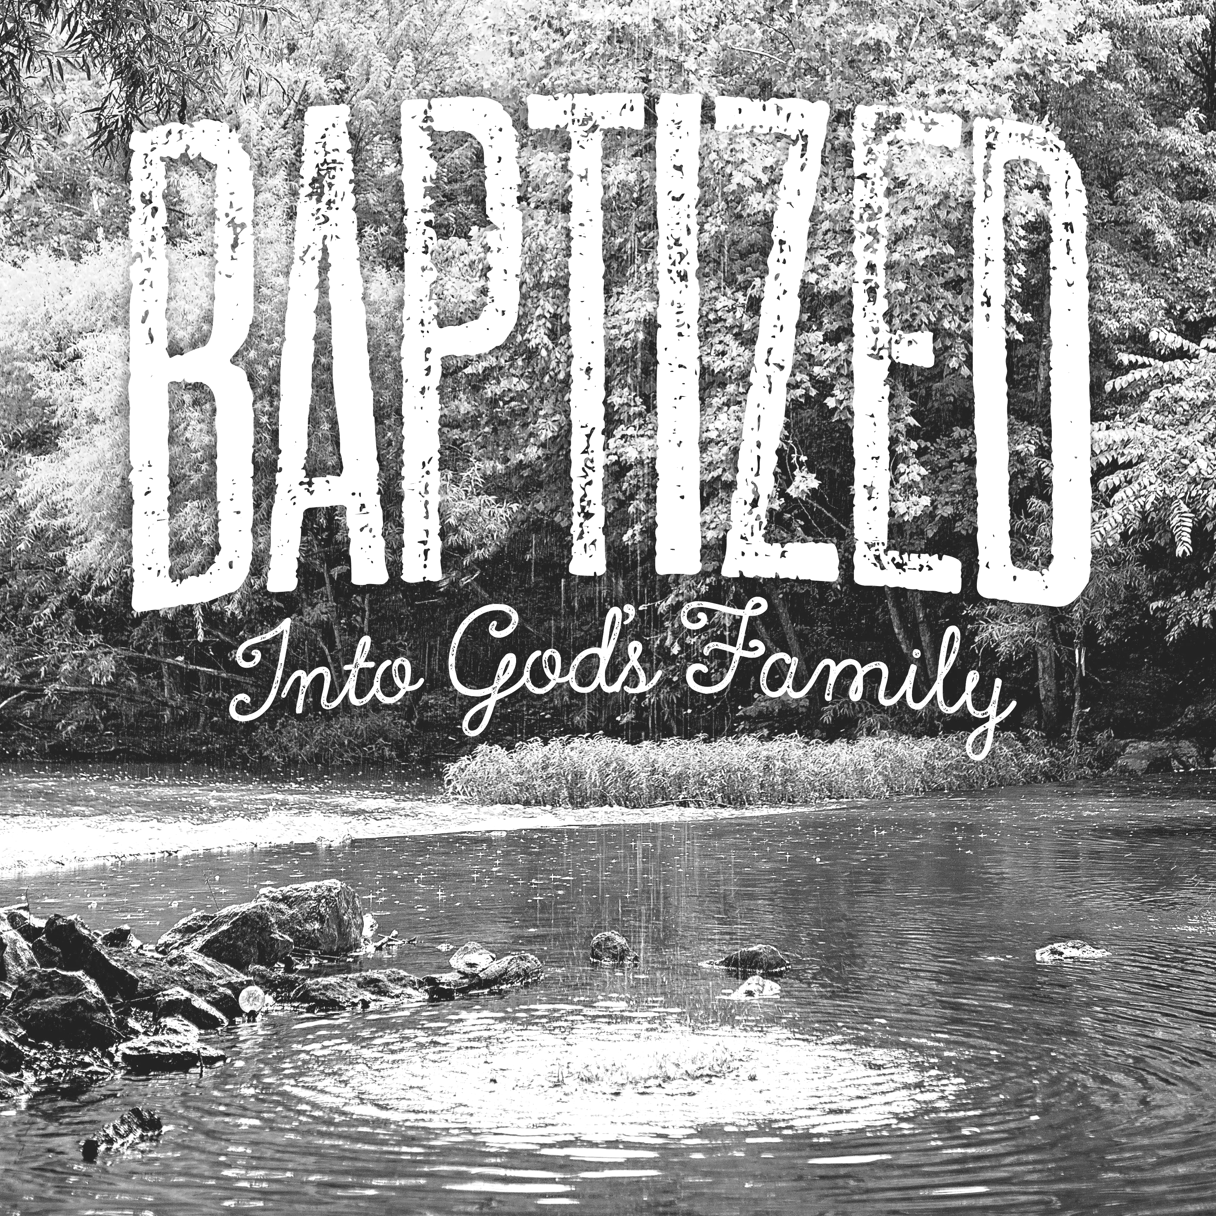



Dr. Bobby Gantt, Pastor
Rev. Scott Haynes, Minister of Music
Tonya Garrison, Minister of Children & Christian Education
David Cox, Minister of Youth & Instructional Technology
Teresa Skinner, Office Manager
Dianne Clayton, Financial Assistant
Ashlee Kallay, Church Hostess
Pam McKeithan, Organist
Sharon Haulk, Pianist
Tommy Wilson, Custodian
Harold Graham, Custodial Assistant
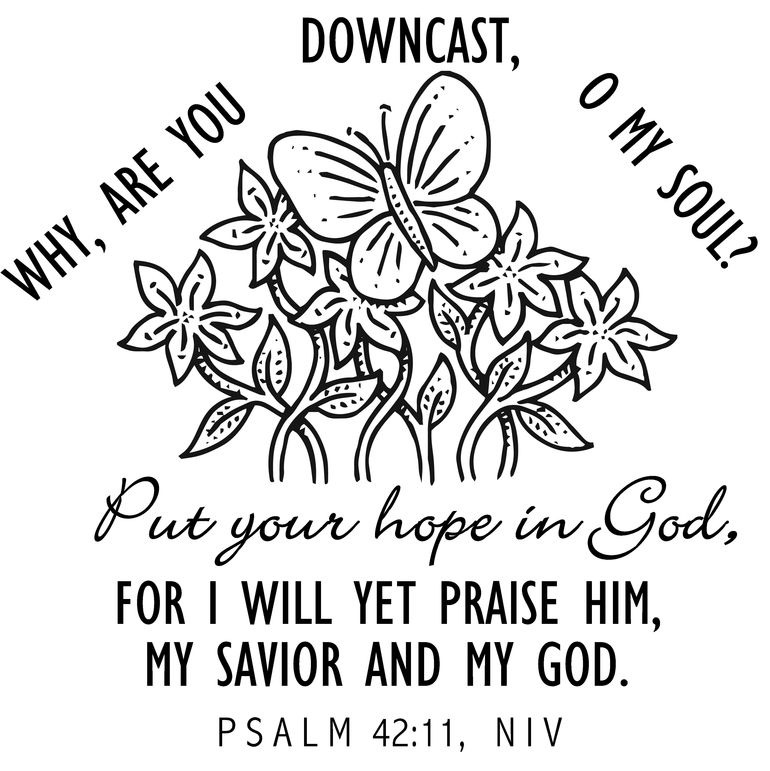

OPPORTUNITIES FOR - February 18-24
SUNDAY: Leviticus 26-27; Matthew 26:57-75
8:45 - First Light (LEC/Gym)
9:45 - Sunday School
11:00 - Salt and Light Service (Sanctuary)
4:00 - G.L.O.W.
5:00 - Youth Praise Band Rehearsal
Jr. G.L.O.W.
6:00 - Power House (The Ark)
Children’s Bible Drill
Youth Bible Study (The Loft)
Adult Handbells
Evening Worship
MONDAY: Numbers 1-2; Matthew 27:1-31
8:30 - 11:00 - LEC/Gym Open for Walkers
5:00 -8:00 -Upward Practice
TUESDAY: Numbers 3-4; Matthew 27:32-66
8:30 - 11:00 - LEC/Gym Open for Walkers
5:00 -8:00 -Upward Practice
6:30 - Knit, Crochet, Pray
WEDNESDAY: Numbers 5-6; Matthew 28
4:30 - Senior Adult Choir
5:00 - Staff Fellowship Supper Serving Time
5:30 - Choir Helpers Fellowship Supper Serving Time
5:45 - 6:15 - Fellowship Supper Serving Time
6:15 - 7:00 - Preschool & Children’s Choirs
6:30 - Prayer Meeting
7:00 - 7:30 - Children’s Mission Groups
7:30 - Adult Choir Rehearsal
8:00 - Adult Praise Band Rehearsal
THURSDAY: Numbers 7; Mark 1:1-15
8:30 - 11:00 - LEC/Gym Open for Walkers
5:00 -8:00 -Upward Practice
FRIDAY: Numbers 8-10; Mark 1:16-45
8:30 - 11:00 - LEC/Gym Open for Walkers
7:00 - 11:30 - Middle School Youth -Big Air Trampoline Park
SATURDAY: Numbers 11-12; Mark 2:1-13
Upward Game @ 2nd Baptist

Let’s Just Praise the Lord
Let’s just praise the Lord! Praise the Lord!
Let’s just lift our hearts to heaven and praise the Lord;
Let’s just praise the Lord! Praise the Lord!
Let’s just lift our hearts to heaven and praise the Lord!

Rejoice in the Lord Always
Rejoice in the Lord always, again I say, rejoice!
Rejoice in the Lord always, again I say, rejoice!
Rejoice! Rejoice! Again I say, rejoice!
Rejoice! Rejoice! Again I say, rejoice!
CCLI#1466496
Sanctuary
Lord, prepare me to be a sanctuary, pure and holy, tried and true
With thanksgiving, I’ll be a living sanctuary for You.
Lord, prepare me to be a sanctuary, pure and holy, tried and true
With thanksgiving, I’ll be a living sanctuary for You.
I’ll be a living sanctuary for You.

This Is the Day
This is the day, this is the day that the Lord has made, that the Lord has made; We will rejoice, we will rejoice and be glad in it, and be glad in it. This is the day that the Lord has made;
We will rejoice and be glad in it. This is the day, this is the day that the Lord has made.

Awesome God
Our God is an awesome God; He reigns from heaven above
With wisdom, pow’r and love; Our God is an awesome God!
Our God is an awesome God; He reigns from heaven above
With wisdom, pow’r and love; Our God is an awesome God!

Children’s Dismissal (4 & 5 Year Olds - 1st & 2nd Graders)
Away in a Manger
Away in a manger, no crib for a bed,
The little Lord Jesus laid down His sweet head.
The stars in the sky looked down where He lay;
The little Lord Jesus asleep on the hay.
CCLI# 1466496



