FIRST LIGHT
FEBRUARY 9, 2020
8:45 A.M. WORSHIP

“And we know that in all things God works for the good of those who love him, who have been called according to his purpose.” Romans 8:28

Praise Set Let the River Flow
He Is Exalted
Children’s Dismissal (4 & 5 Year Olds - 1st & 2nd Graders)
*Offering Hosanna
God with Us
Message Pastor
Anxious? Take Vitamin A!
Romans 8:28; Philippians 4:4-7; James 1:2-4

Invitation Just As I Am
Just a thought: How many of us deal with anxiety? Some people are “worry warts,” but most every person deals with some measure of anxiety, even the most devout Christian. Take biblical Vitamin A!

Accept a basic premise of faith! Romans 8:28
Accept a basic command of Scripture! Philippians 4:6
Accept the joy of the Christian life! James 1:2

As we go: The cure for anxiety? Take Vitamin A! George Mueller said, “The beginning of anxiety is the end of faith, and the beginning of faith is the end of anxiety.”

SALT AND LIGHT
FEBRUARY 9, 2020
11:00 A.M. WORSHIP

Prelude
Call to Worship Comfort Comes
Opening Prayer Tonya Garrison
Hymn #356 Redeemed
Welcome Pastor
Children’s Dismissal (4 & 5 Year Olds - 1st & 2nd Graders)
This Is the Day
This is the day, this is the day that the Lord has made, that the Lord has made; We will rejoice, we will rejoice and be glad in it, and be glad in it. This is the day that the Lord has made;
We will rejoice and be glad in it. This is the day, this is the day that the Lord has made.
CCLI# 1466496
Hymn #624 His Eye Is on the Sparrow
Offertory & Choir Dismissal
Scripture Reading David Cox
Romans 8:28; Philippians 4:4-7; James 1:2-4
Morning Prayer Pastor
Worship in Song Roger Queen
Message Pastor
Anxious? Take Vitamin A!
Invitation Hymn #685 Footsteps of Jesus
Benediction Pastor
Response to Benediction #391 Sweet, Sweet Spirit

6:00 P.M. – Evening Worship
Francis Chan, Letters to the Church
SUNDAY:
8:45 - First Light (LEC)
9:45 - Sunday School
11:00 - Salt and Light Service (Sanctuary)
5:00 – Youth Praise Band
5:00 - G.L.O.W
6:00 - Evening Worship
Powerhouse (4 yr olds – 3rd Graders)
Children’s Bible Drill (4th – 6th Graders)
Youth Discipleship
Adult Handbells

MONDAY:
8:30 - 11:00 - LEC/Gym Open for Walkers
4:00 - 9:00 - Upward Practice
TUESDAY:
8:30 - 11:00 - LEC/Gym Open for Walkers
5:00-8:00 - Upward Practice
WEDNESDAY:
4:30 - Senior Adult Choir
5:00 - Staff Fellowship Supper Serving Time
5:30 - Choir Helpers Fellowship Supper Serving Time
5:45 - 6:15 - Fellowship Supper Serving Time
6:15 - 7:00 - Preschool and Children’s Choirs
6:30 - Prayer Meeting
6:30 - Youth Discipleship
7:00 - Children’s Mission Groups
7:30- Adult Choir Rehearsal
8:30 - Adult Praise Band

THURSDAY:
8:30 - 11:00 - LEC/Gym Open for Walkers
4:00-8:00 - Upward Practice
FRIDAY:
8:30 - 11:00 - LEC/Gym Open for Walkers
SATURDAY:
Upward Game Day - Florence

NURSERY– Sunday, February 9, 2020

8:30 A.M. - Kim Bridges, Jason & Michelle Padgett,
Kerry & Nikki Brock, Maria Hunnicutt
11:00 A.M. - Alyson Mayse, Lauren Hill, Heather Harris,
Libby Fowler, Kathy Key
6:00 P.M. - Kim Bridges, Mary Lib Henson

CHILDREN’S WORSHIP - Sunday, February 9, 2020
8:30 A.M. - Tonya Garrison, Jean Gordon
11:00 A.M. - Tonya Garrison, Rebecca Ennis
FLORENCE BAPTIST CHURCH
201 South Broadway Street, Forest City, North Carolina
828-245-5411
www.florencechurch.net






Dr. Bobby Gantt, Pastor
Jesus, full of the
Holy Spirit…
was led by the Spirit
in the desert,
where for forty days
He was tempted
by the devil

Luke 4:1-2a
Rev. Scott Haynes, Minister of Music
Tonya Garrison, Minister of Children & Christian Education
Rev. David Cox, Minister of Youth & Instructional Technology
Teresa Skinner, Office Manager
Ashlee Kallay, Church Hostess
Pam McKeithan, Organist
Sharon Haulk, Pianist
Tommy Wilson, Custodian
Carrol Calhoun, Custodial Assistant

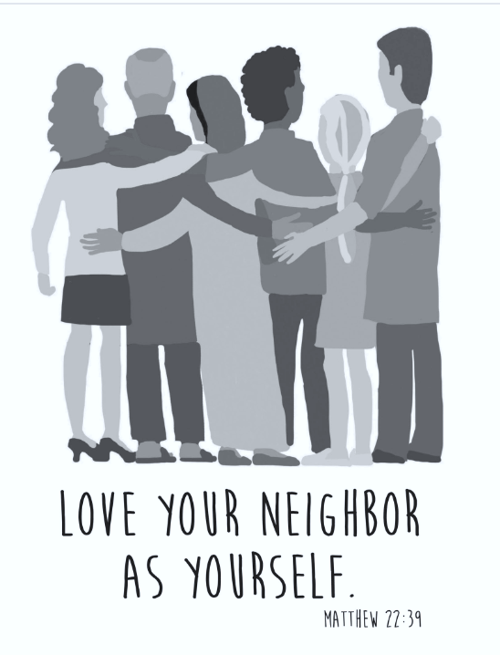

FLORENCE BAPTIST CHURCH
201 South Broadway Street, Forest City, North Carolina
828-245-5411
www.florencechurch.net

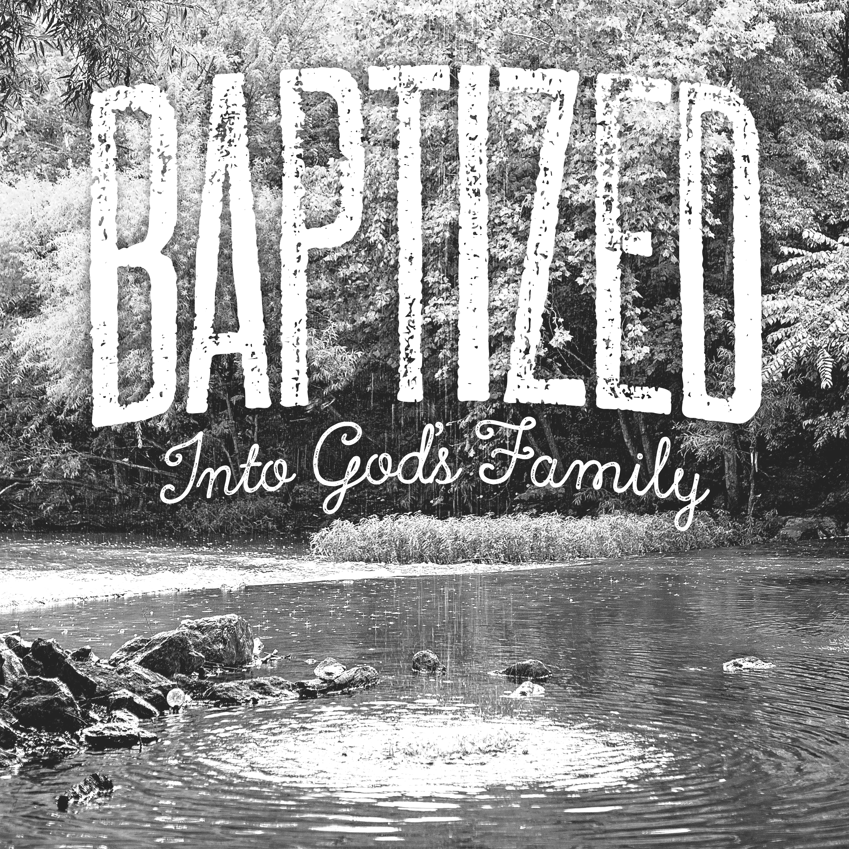



Dr. Bobby Gantt, Pastor
Rev. Scott Haynes, Minister of Music
Tonya Garrison, Minister of Children & Christian Education
David Cox, Minister of Youth & Instructional Technology
Teresa Skinner, Office Manager
Dianne Clayton, Financial Assistant
Ashlee Kallay, Church Hostess
Pam McKeithan, Organist
Sharon Haulk, Pianist
Tommy Wilson, Custodian
Harold Graham, Custodial Assistant
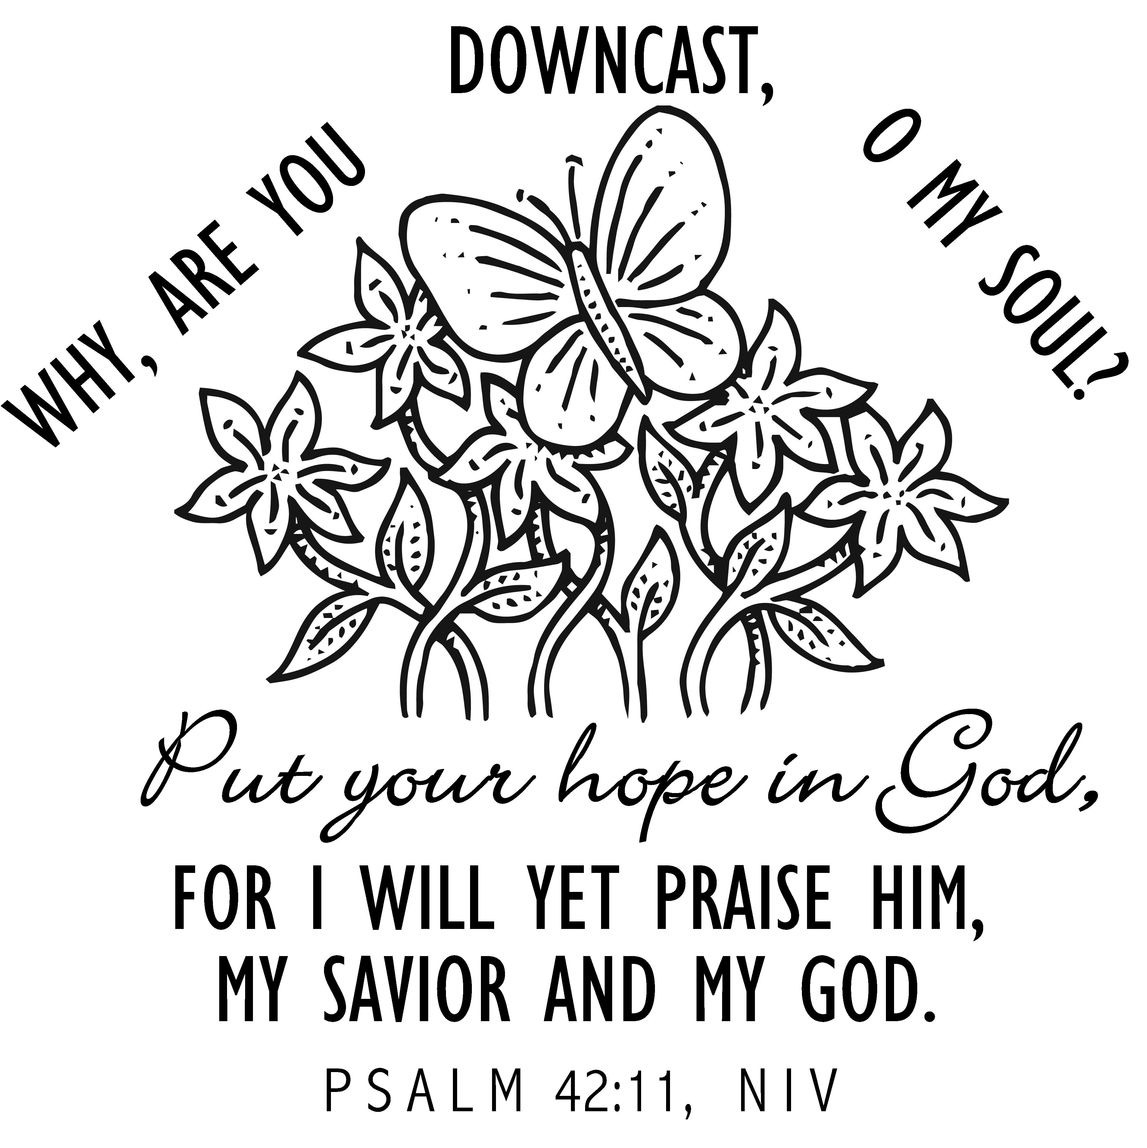

OPPORTUNITIES FOR - February 18-24
SUNDAY: Leviticus 26-27; Matthew 26:57-75
8:45 - First Light (LEC/Gym)
9:45 - Sunday School
11:00 - Salt and Light Service (Sanctuary)
4:00 - G.L.O.W.
5:00 - Youth Praise Band Rehearsal
Jr. G.L.O.W.
6:00 - Power House (The Ark)
Children’s Bible Drill
Youth Bible Study (The Loft)
Adult Handbells
Evening Worship
MONDAY: Numbers 1-2; Matthew 27:1-31
8:30 - 11:00 - LEC/Gym Open for Walkers
5:00 -8:00 -Upward Practice
TUESDAY: Numbers 3-4; Matthew 27:32-66
8:30 - 11:00 - LEC/Gym Open for Walkers
5:00 -8:00 -Upward Practice
6:30 - Knit, Crochet, Pray
WEDNESDAY: Numbers 5-6; Matthew 28
4:30 - Senior Adult Choir
5:00 - Staff Fellowship Supper Serving Time
5:30 - Choir Helpers Fellowship Supper Serving Time
5:45 - 6:15 - Fellowship Supper Serving Time
6:15 - 7:00 - Preschool & Children’s Choirs
6:30 - Prayer Meeting
7:00 - 7:30 - Children’s Mission Groups
7:30 - Adult Choir Rehearsal
8:00 - Adult Praise Band Rehearsal
THURSDAY: Numbers 7; Mark 1:1-15
8:30 - 11:00 - LEC/Gym Open for Walkers
5:00 -8:00 -Upward Practice
FRIDAY: Numbers 8-10; Mark 1:16-45
8:30 - 11:00 - LEC/Gym Open for Walkers
7:00 - 11:30 - Middle School Youth -Big Air Trampoline Park
SATURDAY: Numbers 11-12; Mark 2:1-13
Upward Game @ 2nd Baptist

Let’s Just Praise the Lord
Let’s just praise the Lord! Praise the Lord!
Let’s just lift our hearts to heaven and praise the Lord;
Let’s just praise the Lord! Praise the Lord!
Let’s just lift our hearts to heaven and praise the Lord!

Rejoice in the Lord Always
Rejoice in the Lord always, again I say, rejoice!
Rejoice in the Lord always, again I say, rejoice!
Rejoice! Rejoice! Again I say, rejoice!
Rejoice! Rejoice! Again I say, rejoice!
CCLI#1466496
Sanctuary
Lord, prepare me to be a sanctuary, pure and holy, tried and true
With thanksgiving, I’ll be a living sanctuary for You.
Lord, prepare me to be a sanctuary, pure and holy, tried and true
With thanksgiving, I’ll be a living sanctuary for You.
I’ll be a living sanctuary for You.

This Is the Day
This is the day, this is the day that the Lord has made, that the Lord has made; We will rejoice, we will rejoice and be glad in it, and be glad in it. This is the day that the Lord has made;
We will rejoice and be glad in it. This is the day, this is the day that the Lord has made.

Awesome God
Our God is an awesome God; He reigns from heaven above
With wisdom, pow’r and love; Our God is an awesome God!
Our God is an awesome God; He reigns from heaven above
With wisdom, pow’r and love; Our God is an awesome God!

Children’s Dismissal (4 & 5 Year Olds - 1st & 2nd Graders)
Away in a Manger
Away in a manger, no crib for a bed,
The little Lord Jesus laid down His sweet head.
The stars in the sky looked down where He lay;
The little Lord Jesus asleep on the hay.
CCLI# 1466496



