FIRST LIGHT
DECEMBER 2, 2018
8:45 A.M. WORSHIP

“May God be gracious to us and bless us and make his face shine upon us, that your ways may be known on earth, your salvation among all nations.” Psalm 67:1-2
Praise Set I Will Rise Up
O Come, O Come Emmanuel
Lighting of the Advent Candle Tonya Garrison
Children’s Worship Dismissal (4 & 5 yr. Olds -1st & 2nd Grades)
*Offering O Come All Ye Faithful
What Child Is This?
Message Pastor
Every Church, Every Nation!
Psalm 67:1-7
Invitation Just As I Am

Just a thought: Our mission as a church is to share the Gospel with every person and every nation! Psalm 67 calls us to be on mission to the entire world. The Psalm reminds us of:
The Greatest Gift!
The Greatest Privilege!
The Greatest Joy!
As we go: As we celebrate Christmas and the birth of Jesus Christ, let’s share this most precious gift with our world through our time, talents and resources!

SALT AND LIGHT
DECEMBER 2, 2018
11:00 A.M. WORSHIP

Prelude
Call to Worship Good King Wenceslas
Adult Handbells
Opening Prayer Tonya Garrison
Hymn #278 Angels We Have Heard on High
Welcome Pastor
Lighting of the Advent Candle Tonya Garrison
Children’s Worship Dismissal (4 & 5 yr. Olds -1st & 2nd Grades)

Away in a Manger
Away in a manger, no crib for a bed, the little Lord Jesus lay down His sweet head. The stars in the sky look down where he lay; The little Lord Jesus, asleep on the hay.
The cattle are lowing, the Baby awakes, But little Lord Jesus no crying He makes. I love Thee, Lord Jesus; look down from the sky, and stay by my cradle ‘til morning is nigh.
CCLI#1466496
Hymn #273 Good Christian Men Rejoice
Offertory O Holy Night
Scripture Reading Psalm 67:1-7 David Cox
Morning Prayer Pastor
Worship in Song The Moon of Wintertime
Message Every Church, Every Nation! Pastor
Invitation Hymn #581 ‘Tis So Sweet to Trust in Jesus
Benediction Pastor
Response to Benediction #277 Hark the Herald Angels Sing
EVENING WORSHIP - SANCTUARY – 6:00 P.M.
Star Search – Children’s Choirs

OPPORTUNITIES FOR - December 2-8

SUNDAY:
8:45 - First Light (LEC/Gym)
9:45 - Sunday School
11:00 - Salt and Light Service (Sanctuary)
4:00 - G.L.O.W
5:00 - Junior G.L.O.W.
6:00 - Evening Service, Star Search
Children’s Choirs

MONDAY:
8:30 - 11:00 - LEC/Gym Open for Walkers
5:00 - 8:00 Upward Practices

TUESDAY:
8:30 - 11:00 - LEC/Gym Open for Walkers
12:00 - Senior Adult Luncheon
5:00 - 8:00 Upward Practices
6:30 - Knit, Crochet, Pray

WEDNESDAY:
4:30 - Senior Adult Choir
5:00 - Staff Fellowship Supper Serving Time
5:30 - Choir Helpers Fellowship Supper Serving Time
5:45 - 6:15 - Fellowship Supper Serving Time
6:15 - 7:00 - Preschool & Children’s Choirs
6:30 - Prayer Meeting
6:30 - 7:30 - Youth Activities
7:00 - 7:30 Children’s Mission Activities
7:30 - Adult Choir Rehearsal
8:00 - Adult Praise Band

THURSDAY:
8:30 - 11:00 - LEC/Gym Open for Walkers
10:00 - GriefShare
5:00 - 8:00 Upward Practices

FRIDAY:
8:30 - 11:00 - LEC/Gym Open for Walk

NURSERY– December 2, 2018
8:30 A.M. - Kim Bridges, Travis & Jessica Haynes,
Terry & Tracy Self
11:00 A.M. - Alyson Mayse, Tommy & Erin Wilson,
Chuck & Stephanie Hardin
6:00 P.M. - Kim Bridges, Barbara Blue

CHILDREN’S WORSHIP - December 2, 2018
8:45 A.M. - Tonya Garrison, Christina Green
11:00 A.M. - Tonya Garrison, Jean Gordon

FLORENCE BAPTIST CHURCH
201 South Broadway Street, Forest City, North Carolina
828-245-5411
www.florencechurch.net

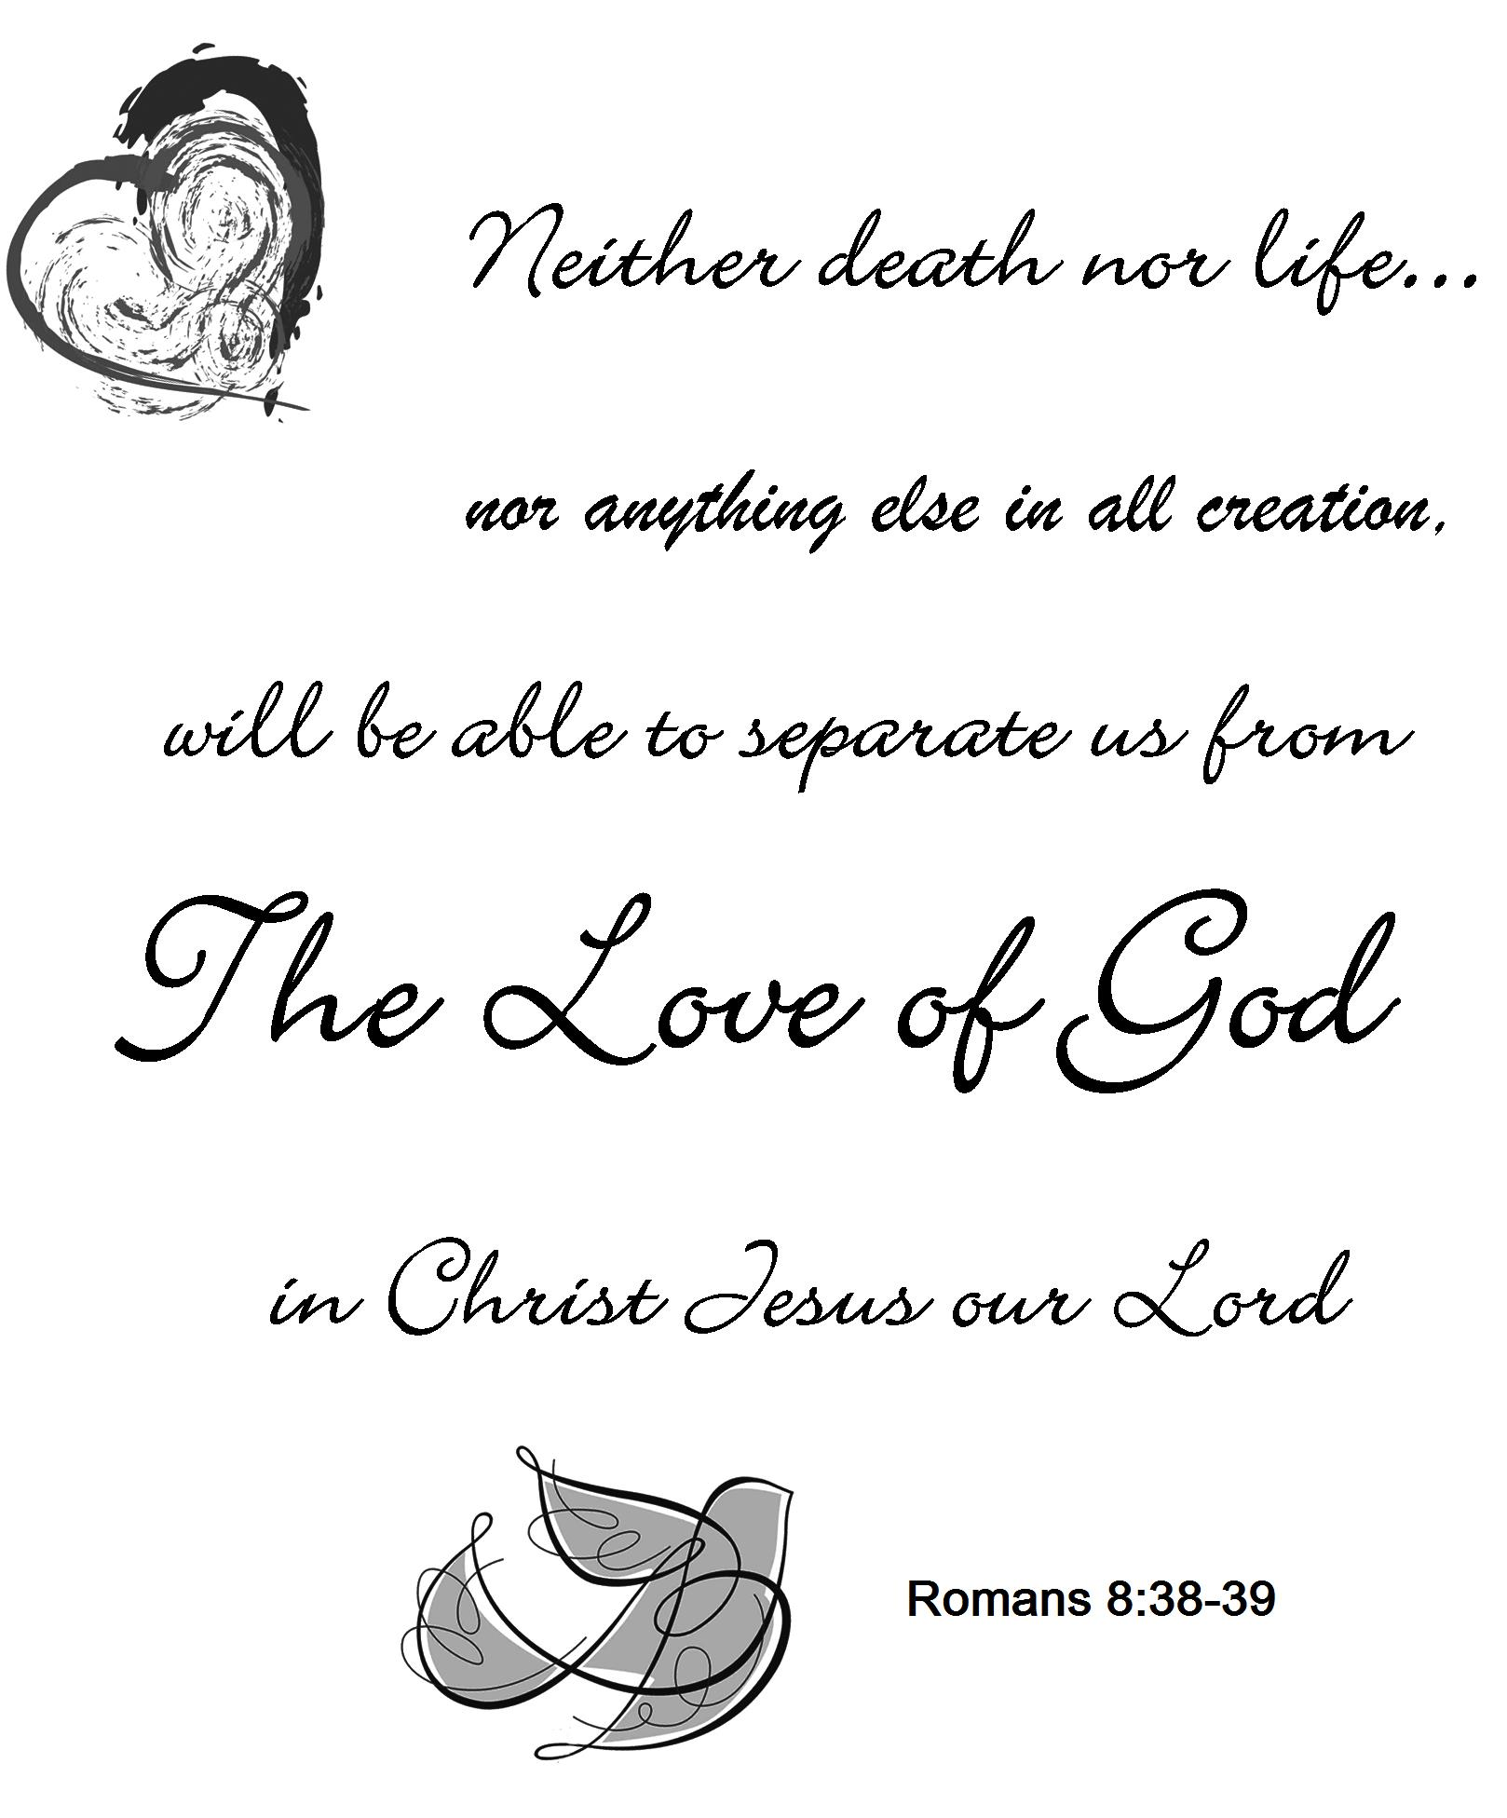

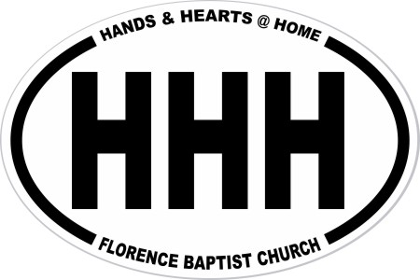
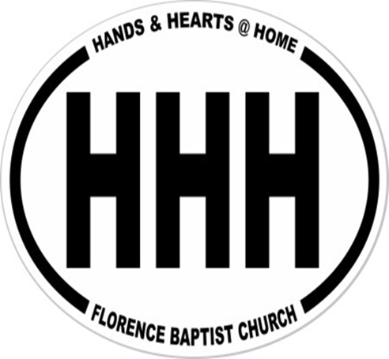
Dr. Bobby Gantt, Pastor
Rev. Scott Haynes, Minister of Music
Tonya Garrison, Minister of Children & Christian Education
David Cox, Minister of Youth & Instructional Technology
Teresa Skinner, Office Manager
Ashlee Kallay, Church Hostess
Pam McKeithan, Organist
Sharon Haulk, Pianist
Tommy Wilson, Custodian
Harold Graham, Custodial Assistant

FLORENCE BAPTIST CHURCH
201 South Broadway Street, Forest City, North Carolina
828-245-5411
www.florencechurch.net

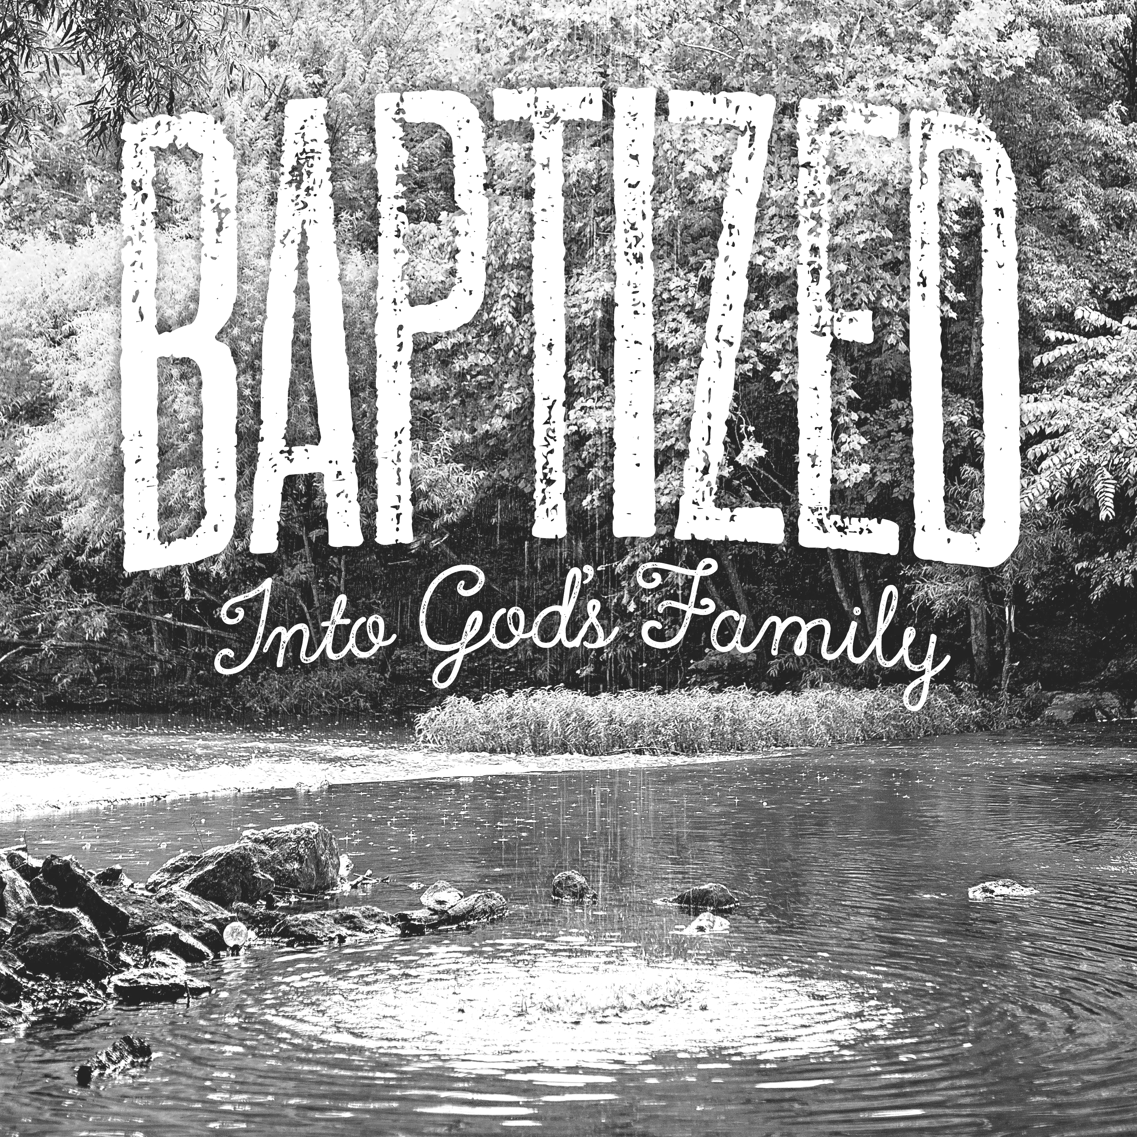



Dr. Bobby Gantt, Pastor
Rev. Scott Haynes, Minister of Music
Tonya Garrison, Minister of Children & Christian Education
David Cox, Minister of Youth & Instructional Technology
Teresa Skinner, Office Manager
Dianne Clayton, Financial Assistant
Ashlee Kallay, Church Hostess
Pam McKeithan, Organist
Sharon Haulk, Pianist
Tommy Wilson, Custodian
Harold Graham, Custodial Assistant


OPPORTUNITIES FOR - February 18-24
SUNDAY: Leviticus 26-27; Matthew 26:57-75
8:45 - First Light (LEC/Gym)
9:45 - Sunday School
11:00 - Salt and Light Service (Sanctuary)
4:00 - G.L.O.W.
5:00 - Youth Praise Band Rehearsal
Jr. G.L.O.W.
6:00 - Power House (The Ark)
Children’s Bible Drill
Youth Bible Study (The Loft)
Adult Handbells
Evening Worship
MONDAY: Numbers 1-2; Matthew 27:1-31
8:30 - 11:00 - LEC/Gym Open for Walkers
5:00 -8:00 -Upward Practice
TUESDAY: Numbers 3-4; Matthew 27:32-66
8:30 - 11:00 - LEC/Gym Open for Walkers
5:00 -8:00 -Upward Practice
6:30 - Knit, Crochet, Pray
WEDNESDAY: Numbers 5-6; Matthew 28
4:30 - Senior Adult Choir
5:00 - Staff Fellowship Supper Serving Time
5:30 - Choir Helpers Fellowship Supper Serving Time
5:45 - 6:15 - Fellowship Supper Serving Time
6:15 - 7:00 - Preschool & Children’s Choirs
6:30 - Prayer Meeting
7:00 - 7:30 - Children’s Mission Groups
7:30 - Adult Choir Rehearsal
8:00 - Adult Praise Band Rehearsal
THURSDAY: Numbers 7; Mark 1:1-15
8:30 - 11:00 - LEC/Gym Open for Walkers
5:00 -8:00 -Upward Practice
FRIDAY: Numbers 8-10; Mark 1:16-45
8:30 - 11:00 - LEC/Gym Open for Walkers
7:00 - 11:30 - Middle School Youth -Big Air Trampoline Park
SATURDAY: Numbers 11-12; Mark 2:1-13
Upward Game @ 2nd Baptist

Rejoice in the Lord Always
Rejoice in the Lord always, again I say, rejoice!
Rejoice in the Lord always, again I say, rejoice!
Rejoice! Rejoice! Again I say, rejoice!
Rejoice! Rejoice! Again I say, rejoice!
CCLI#1466496



