FIRST LIGHT
OCTOBER 7, 2018
8:45 A.M. WORSHIP

“So then, just as you received Christ Jesus as Lord, continue to live your lives in him, rooted and built up in him, strengthened in the faith as you were taught, and overflowing with thankfulness.”
Colossians 2:6-7

Praise Set Jesus, Mighty God

Can’t Stop Singing

Children’s Worship Dismissal (4 & 5 yr. Olds -1st & 2nd Grades)

*Offering Same Power

More Love, More Power

Message David Cox
A Christ Centered Life
Colossians 2:6-15

Invitation Just As I Am

Just a thought: There are so many things in this world that pull us away from Christ. We are easily tempted to center our lives on things of lesser importance. This leaves us without fulfillment and joy. However, in Christ we have all we ever need for life and godliness. A life of joy and fulfillment is one centered on Christ and His Gospel.

SALT AND LIGHT
OCTOBER 7, 2018
11:00 A.M. WORSHIP

Prelude
Call to Worship There’s A Crown Awaiting
Opening Prayer Tonya Garrison
Hymn #391 Sweet, Sweet Spirit
Welcome Tonya Garrison
Children’s Worship Dismissal (4 & 5 yr. Olds -1st & 2nd Grades)
Sanctuary
Lord, prepare me to be a sanctuary, pure and holy, tried and true;
With thanksgiving, I’ll be a living sanctuary for You.
Lord, prepare me to be a sanctuary, pure and holy, tried and true;
With thanksgiving, I’ll be a living sanctuary for You.
With thanksgiving, I’ll be a living sanctuary for You.
CCLI#1466496
Hymn #571 Trust and Obey
Offertory
Scripture Reading Colossians 2:6-15 David Cox
Morning Prayer David Cox
Worship in Song Cassidy Jones
Message David Cox
A Christ Centered Life

Invitation Hymn #638 I Need Thee Every Hour

Benediction David Cox

Response to Benediction #391 Sweet, Sweet Spirit

The flowers in the Sanctuary have been placed in memory of Linda Chapa and Ruby Collins by Mike and Frieda Chapa.
EVENING WORSHIP
SANCTUARY – 6:00 P.M.

OPPORTUNITIES FOR - October 7– October 13

SUNDAY:
8:45 - First Light (LEC/Gym)
9:45 - Sunday School
11:00 - Salt and Light Service (Sanctuary)
4:00 - G.L.O.W
5:00-Youth Praise Band
5:00 - Missions Committee Meeting
6:00 - Evening Service
PowerHouse (4 year olds - 3rd Grade)
Children’s Bible Drill (4th-6th grades)
Youth Discipleship
Adult Handbells

MONDAY:
8:30 - 11:00 - LEC/Gym Open for Walkers

TUESDAY:
8:30 - 11:00 - LEC/Gym Open for Walkers

WEDNESDAY:
4:30 - Senior Adult Choir
5:30 - Children’s Choir Leaders Serving Time
5:45 - 6:15 Fellowship Supper Serving Time
6:15 - 7:00 Preschool and Children’s Choirs
6:30 - Prayer Meeting
6:30 - 7:30 - Youth Activities
7:00 - 7:30 - Children’s Mission Activities
7:30 Adult Choir Rehearsal
8:30 - Adult Praise Band Rehearsal

THURSDAY:
8:30 - 11:00 - LEC/Gym Open for Walkers

FRIDAY:
8:30 - 11:00 - LEC/Gym Open for Walkers
After the Game - Youth 5th Quarter
NURSERY– October 7, 2018
8:30 A.M. - Gina Greene, Angela Dufford, Maria Hunnicut, Missy Flack,
Connie Champion
11:00 A.M. - April Mayse, Brandon & Kara Ellenburg,
Chuck & Stephanie Hardin
6:00 P.M. - Kim Bridges, John & Angela Dufford

CHILDREN’S WORSHIP - October 7, 2018
8:45 A.M. - Tonya Garrison, Laura Harris
11:00 A.M. - Tonya Garrison, Vanessa Wiig

POWERHOUSE - October 7, 2018
6:00 P.M. - Alyson Mayse and April Mayse
FLORENCE BAPTIST CHURCH
201 South Broadway Street, Forest City, North Carolina
828-245-5411
www.florencechurch.net

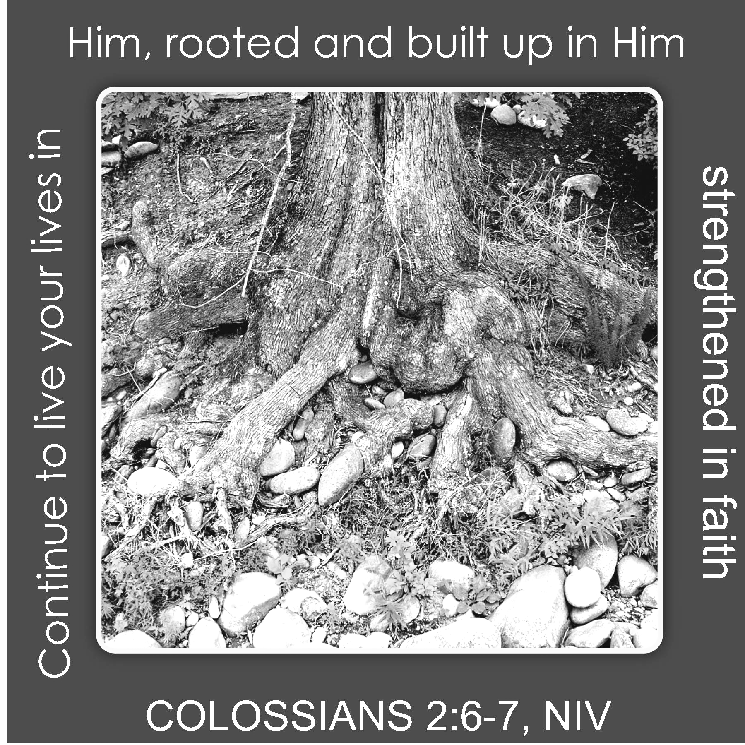

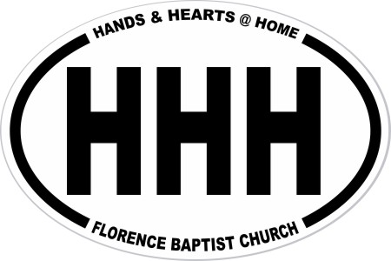
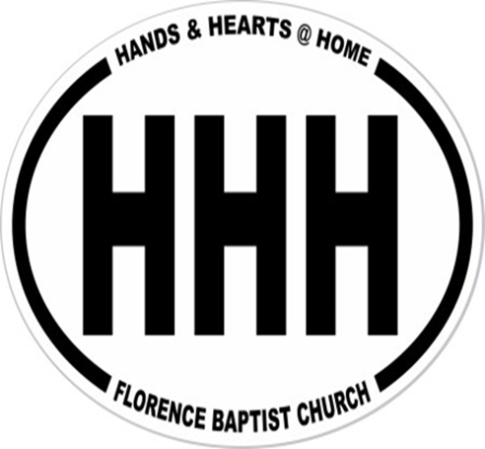
Dr. Bobby Gantt, Pastor
Rev. Scott Haynes, Minister of Music
Tonya Garrison, Minister of Children & Christian Education
David Cox, Minister of Youth & Instructional Technology
Teresa Skinner, Office Manager
Ashlee Kallay, Church Hostess
Pam McKeithan, Organist
Sharon Haulk, Pianist
Tommy Wilson, Custodian
Harold Graham, Custodial Assistant

FLORENCE BAPTIST CHURCH
201 South Broadway Street, Forest City, North Carolina
828-245-5411
www.florencechurch.net



Dr. Bobby Gantt, Pastor
Rev. Scott Haynes, Minister of Music
Tonya Garrison, Minister of Children & Christian Education
David Cox, Minister of Youth & Instructional Technology
Teresa Skinner, Office Manager
Dianne Clayton, Financial Assistant
Ashlee Kallay, Church Hostess
Pam McKeithan, Organist
Sharon Haulk, Pianist
Tommy Wilson, Custodian
Harold Graham, Custodial Assistant



OPPORTUNITIES FOR - February 18-24
SUNDAY: Leviticus 26-27; Matthew 26:57-75
8:45 - First Light (LEC/Gym)
9:45 - Sunday School
11:00 - Salt and Light Service (Sanctuary)
4:00 - G.L.O.W.
5:00 - Youth Praise Band Rehearsal
Jr. G.L.O.W.
6:00 - Power House (The Ark)
Children’s Bible Drill
Youth Bible Study (The Loft)
Adult Handbells
Evening Worship
MONDAY: Numbers 1-2; Matthew 27:1-31
8:30 - 11:00 - LEC/Gym Open for Walkers
5:00 -8:00 -Upward Practice
TUESDAY: Numbers 3-4; Matthew 27:32-66
8:30 - 11:00 - LEC/Gym Open for Walkers
5:00 -8:00 -Upward Practice
6:30 - Knit, Crochet, Pray
WEDNESDAY: Numbers 5-6; Matthew 28
4:30 - Senior Adult Choir
5:00 - Staff Fellowship Supper Serving Time
5:30 - Choir Helpers Fellowship Supper Serving Time
5:45 - 6:15 - Fellowship Supper Serving Time
6:15 - 7:00 - Preschool & Children’s Choirs
6:30 - Prayer Meeting
7:00 - 7:30 - Children’s Mission Groups
7:30 - Adult Choir Rehearsal
8:00 - Adult Praise Band Rehearsal
THURSDAY: Numbers 7; Mark 1:1-15
8:30 - 11:00 - LEC/Gym Open for Walkers
5:00 -8:00 -Upward Practice
FRIDAY: Numbers 8-10; Mark 1:16-45
8:30 - 11:00 - LEC/Gym Open for Walkers
7:00 - 11:30 - Middle School Youth -Big Air Trampoline Park
SATURDAY: Numbers 11-12; Mark 2:1-13
Upward Game @ 2nd Baptist

Rejoice in the Lord Always
Rejoice in the Lord always, again I say, rejoice!
Rejoice in the Lord always, again I say, rejoice!
Rejoice! Rejoice! Again I say, rejoice!
Rejoice! Rejoice! Again I say, rejoice!
CCLI#1466496



